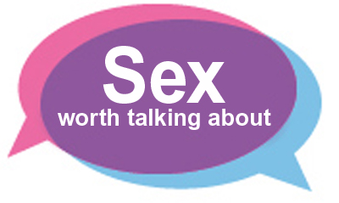

SAVE THE DATE!

Sexual Health Update - Thursday 14th September 2017

Venue: The Lakehouse, Ron Cooke Hub, University of York, Heslington, YO10 5GE (free parking after 18hrs)
Times: 18.30 registration and refreshments, 19.00 presentations commence, 20.30 close
Chair: Dr Emma Broughton, PMG

Presentations by clinicians from YorSexualHealth include:

- Emergency Contraception Update
- Recent trends in syphilis
- HIV testing

There will also be workshops for smaller groups covering Sayana Press, Caya diaphragm, Jaydess IUD, post sexual exposure HIV prophylaxis (PEPSE) and pre exposure HIV prophylaxis (PrEP).

For more information or to book your place please contact Ellie Homes:

E: ellie.holmes1@nhs.net
T: 07899753784
W: www.wpem.co.uk

