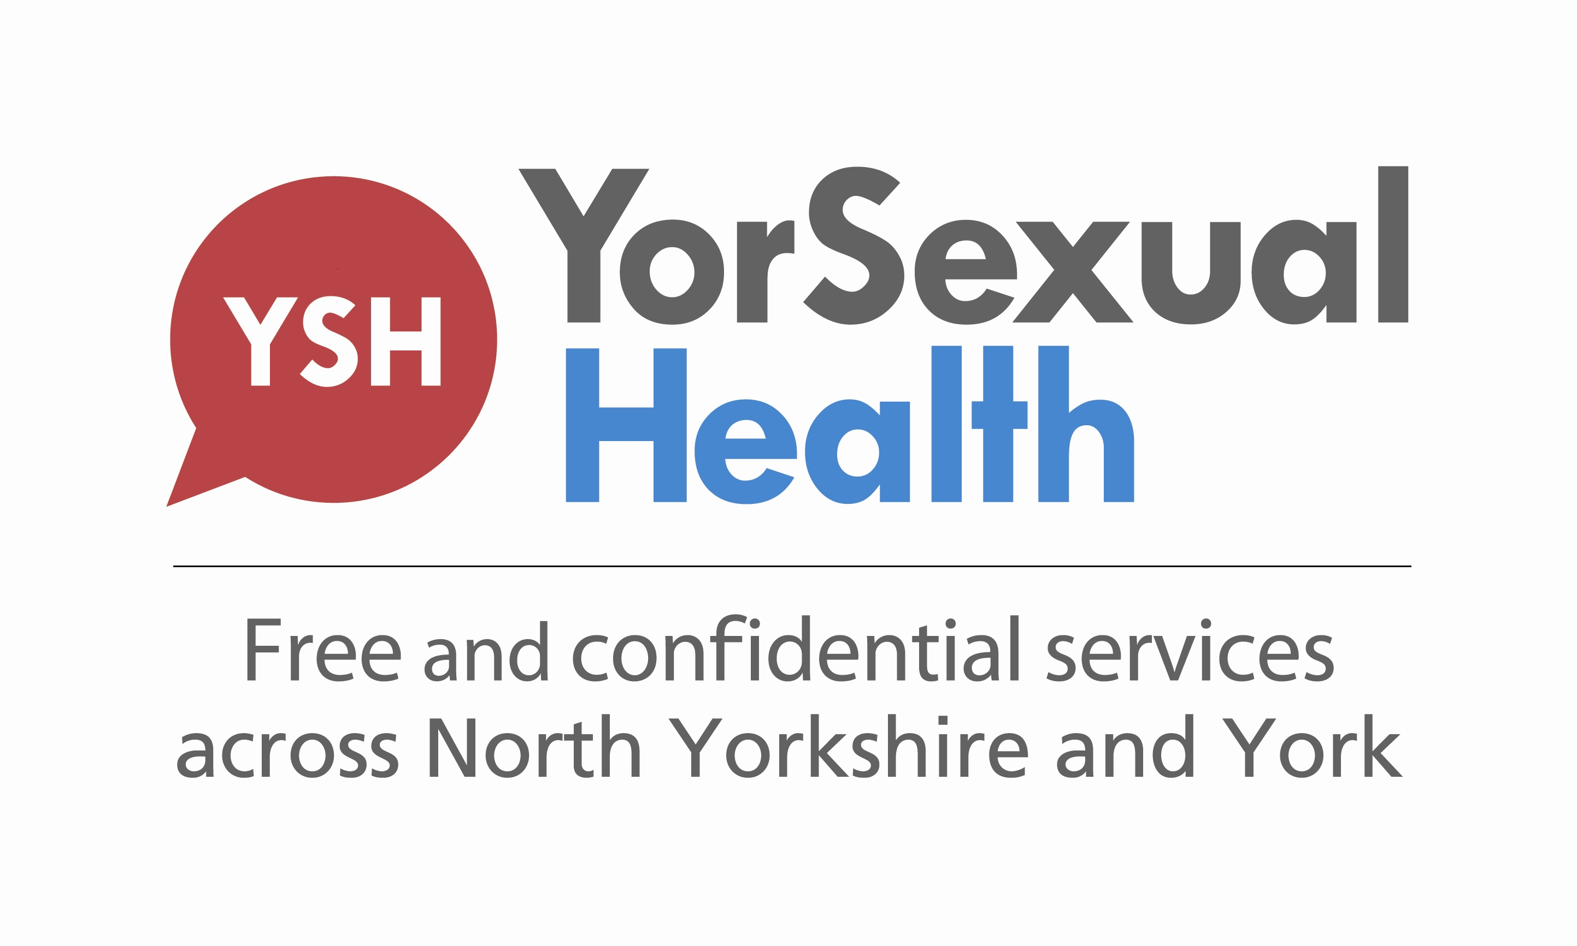

Specialist Clinical and Community Outreach Team referral criteria

The Specialist Clinical and Community Outreach Team (SCCOT) aims to meet the sexual health needs of young and vulnerable people, and to support colleagues and other professionals when providing sexual health care to these groups.

We will offer clinical care, training, and guidance and advice about sexual health.

The team provides this service in York and North Yorkshire, with named nurses allocated to each locality.

Any safeguarding concerns for adults or children should be managed according to local policy. A referral can then be made to SCCOT for clinical sexual health care.

To discuss or make a referral:

Telephone: 01904 725436
Email: yhs-tr.sccot@nhs.net

Further information about all Yorsexual Health services in York and North Yorkshire can be found at yorsexualhealth.org.uk

Criteria for referral to SCCOT:

- Young and vulnerable people who are at high risk of unintended pregnancy or sexually transmitted infection, and who may require additional support (e.g. individuals who are hard to reach and who may have difficulty in accessing sexual health services).

- Young and vulnerable people who have untreated/inadequately treated sexually transmitted infections, or unintended pregnancy, and need support in accessing sexual health services

- Young and vulnerable people for whom the referrer suspects, or has concerns, that grooming/sexual exploitation is taking place and clinical advice/support is required

- Young and vulnerable people who have disclosed sexual assault and clinical follow up/support is required. The referrer receiving the disclosure of sexual assault is advised to follow their own agencies safeguarding policies in relation to such a disclosure.

- Children under the age of 13 years who are sexually active. The referrer is advised to follow their own agencies child safeguarding policy as children under 13 years are legally unable to give consent to sexual activity, therefore any sexual intercourse with a child under 13 years is rape and requires referral to children’s safeguarding services.

